## **Embedding Power BI Reports in SPFX Web Parts**

**Setup Time**: 60 minutes

**Lab Folder**: C:\Student\Modules\08_PBIEmbedding\Lab

**Overview**: In this lab you will work through the steps to develop a custom web application that embeds Power BI reports and dashboards. You will begin by creating an app workspace and populating it embeddable Power BI resources including a dataset, a report and a dashboard. Next, you will register a new application with Azure AD in the Azure portal and configure this Azure AD application with the proper permissions to program using the Power BI Service API. After that, you will create a new web application using Visual Studio 2017 and ASP.NET MVC. As you move through the exercises of this lab, you will program against both the Power BI Service API and the Power BI JavaScript API to implement the required steps to embed Power BI reports and dashboards into your custom web application.

### Exercise 1: Create a New App Workspace and Populate It with Content

In this exercise, you will create a new app workspace and then you will work to populate this workspace with embeddable content which will include a dataset, a report and a dashboard.

1. Make sure you are logged into the Power BI service with your primary Office 365 user account.
2. Create a new app workspace named **Embedded Lab**.
   1. Click the **Workspace** flyout menu in the left navigation.

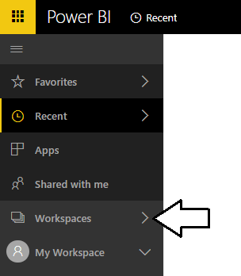

* 1. Click the **Create app workspace** button to display the **Create an app workspace** dialog.

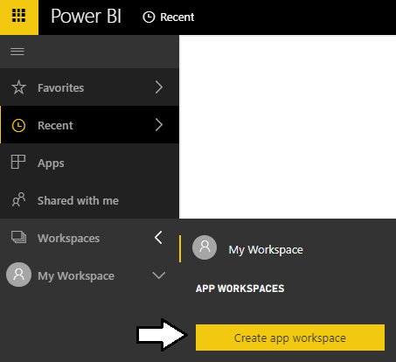

* 1. In the **Create an app workspace** pane, enter a name of **Embedded Lab**.
  2. Accept all the other default settings and click **Save**.

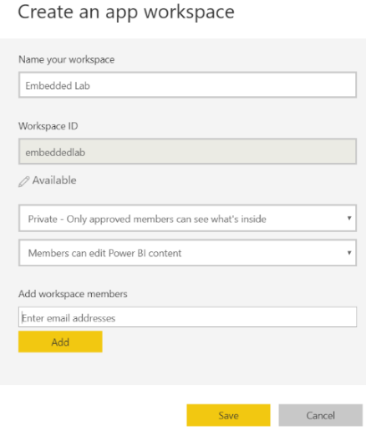

When you create a new app workspace, the account you are logged in as is automatically added as a workspace admin.

* 1. When you click **Save**, the Power BI service should create the new app workspace and then switch your current Power BI session to be running within the context of this new workspace named **Embedded Lab**.

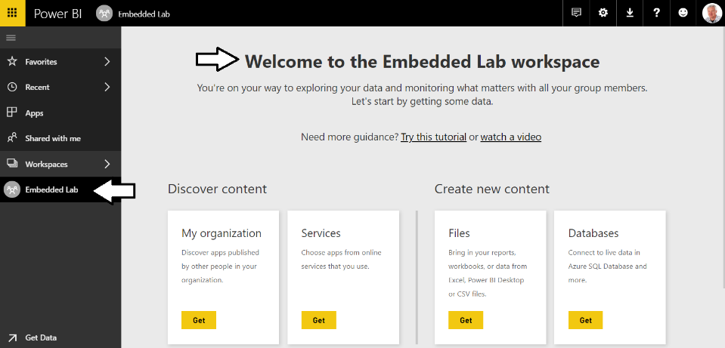

By creating a new workspace, you have effectively created new container for a new set of datasets, reports and dashboards.

1. Import the **Wingtip Sales Analysis.pbix** project into the **Embedded** app workspace.
   1. Using Windows Explorer, verify there is a PBIX file named **Wingtip Sales Analysis.pbix** at the following path.

C:\Student\Projects\Wingtip Sales Analysis.pbix

* 1. If you do not have a local copy of the **Student** folder, you can download this PBIX filefrom [here](https://github.com/CriticalPathTraining/PBD365/raw/master/Projects/Wingtip%20Sales%20Analysis.pbix).
  2. In the Power BI Service, click the **Get** button in the **Files** section of the Welcome page.

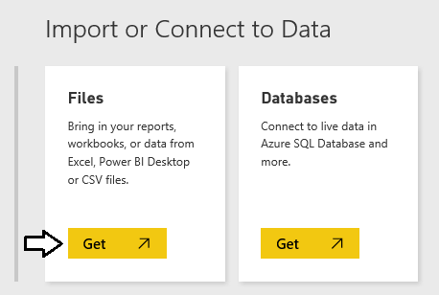

* 1. On the **Get Data > Files** page, click the **Local File** button to display the Windows **Open** file dialog.

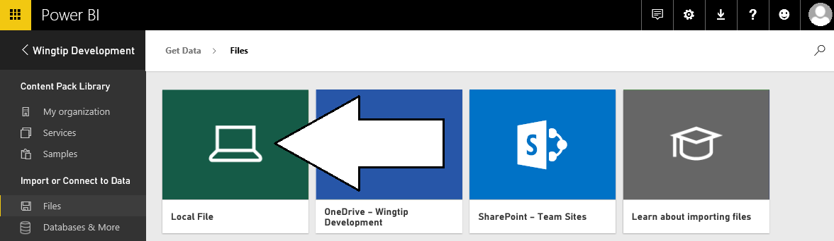

* 1. In the Windows **Open** file dialog, select the project file at **c:\Student\PBIX\Wingtip Sales Analysis.pbix** and click **Open**.

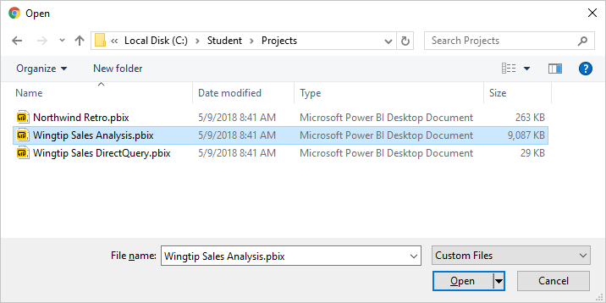

* 1. Wait while the Power BI service uploads the PBIX files and imports its assets into the **Embedded Lab** app workspace

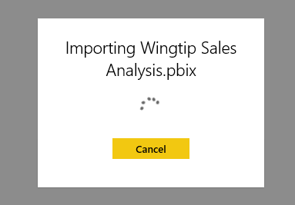

* 1. Once the import process completes, you’ll see a new dataset, a new report and a new dashboard in the left navigation menu.

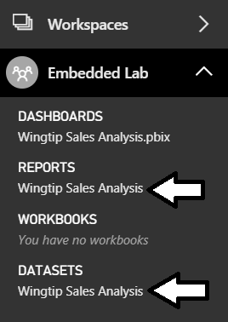

1. Remove the dashboard that was created during the import process.
   1. Dropdown the flyout menu for the **Wingtip Sales Analysis.pbix** dashboard and click the **REMOVE** menu command.

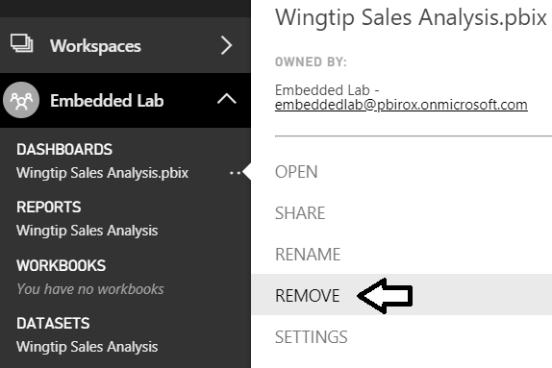

* 1. Confirm that you want to delete the dashboard by clicking the **Delete** button the **Delete dashboard** dialog.

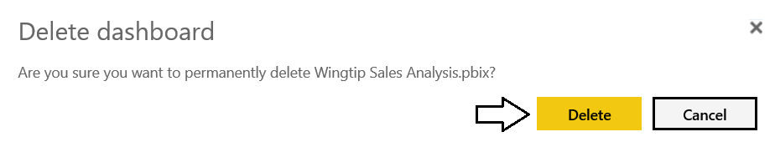

* 1. You should be able to confirm that the dashboard has been removed.

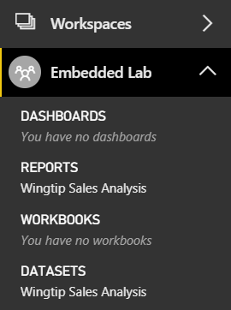

1. Click on the report named **Wingtip Sales Analysis** in the **Reports** section. Examine the pages in the report.

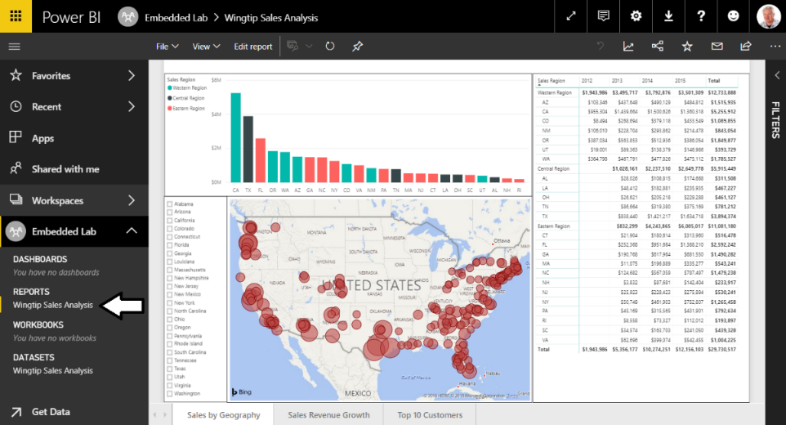

1. Click on the dataset named **Wingtip Sales Analysis** in the **Datasets** section. The Power BI service responds by displaying a new report that allows you to begin adding visuals.

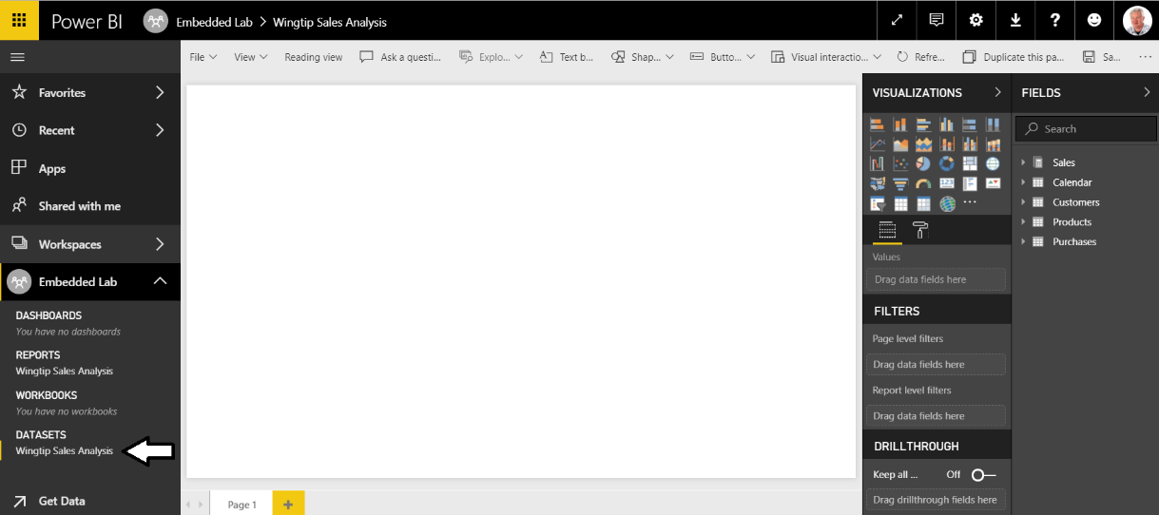

When you navigate to a dataset in the Power BI service, it provides a different experience compared to when in Power BI Desktop. That’s because Power BI Desktop allows you to customize and extend a dataset while the browser-based experience of the Power BI Service only allows you to consume datasets but not to modify them. Given the fact that a dataset is a read-only object, the Power BI Service responds to user’s request to navigate to a dataset by opening a new report and showing the **Fields** list for that dataset.

1. Create a new Dashboard named **Wingtip Sales Analysis**.
   1. Navigate to the **Sales by Geography** page of the **Wingtip Sales Analysis** report.
   2. Inspect the Stacked column chart which displays a sales revenue breakdown across sales regions and product categories.
   3. Locate and click the button with the thumbtack icon which is used to pin a report visualization to a dashboard.

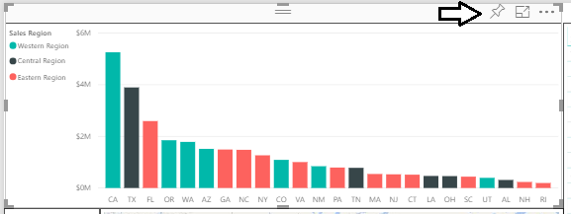

* 1. When you click the thumbtack button, you will be prompted with the dialog which asks you where to pin the visualization.
  2. Select **New Dashboard**, give it a name of **Wingtip Sales Analysis** and click the **Pin** button.

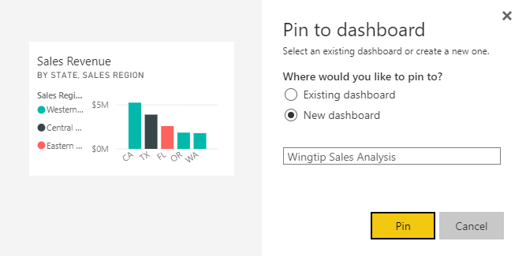

* 1. At this point, the **Wingtip Sales Analysis** dashboard should be created and a link to it should appear in the left navigation.

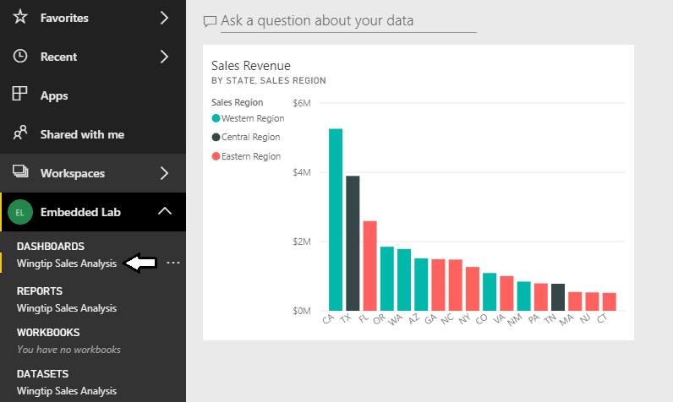

* 1. Repeat the process several times of pinning a visual from the report to create new dashboard tiles. Choose whatever visuals you’d like from the report but make sure your dashboard contains at least 4 to 5 tiles as shown in the following screenshot.

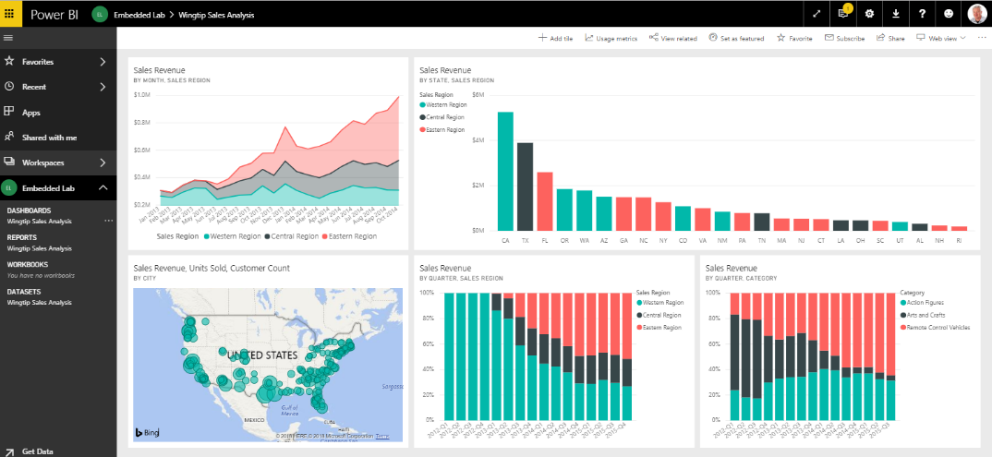.

Now that you have finished preparing the app workspace with the content you will use for Power BI embedding, you must record a few key pieces of configuration data you will need later in this lab. First, you will record which Active Directory user account you will use as the master user account. Next, you will record the identifying GUID for the **Embedded Lab** app workspace and the identifying GUIDs for the dataset, report and dashboard you created inside this app workspace.

1. Record configuration data that you will need later in this lab.
   1. Locate the configuration file named **EmbeddingConfigurationData.txt** which is located at the following path.

C:\Student\Modules\08_PBIEmbedded\Lab\EmbeddingConfigurationData.txt

* 1. Open **EmbeddingConfigurationData.txt** using Widows Notepad and inspect it contents. It contains the names of 7 essential pieces of configuration data you will need later in this lab.

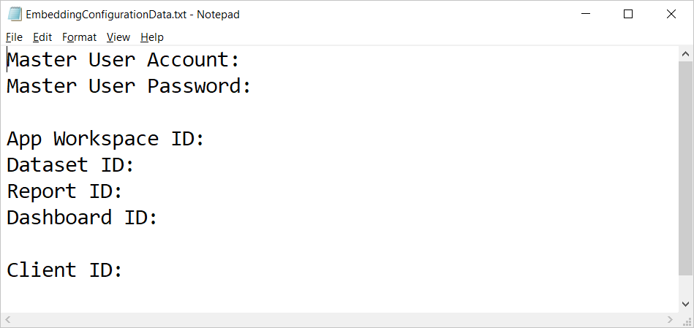

* 1. Complete the top two lines by adding the name of your primary Office 365 account and the password for your account.
  2. Navigate to the **Wingtip Sales Analysis** report inside the **Embedded Lab** app workspace.
  3. Locate and copy the app workspace ID from the URL by copy the GUID that comes after **/groups/**.

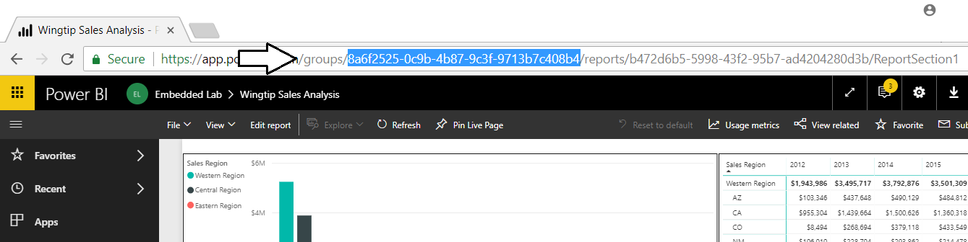

* 1. Copy the app workspace ID into **EmbeddingConfigurationData.txt**.
  2. Navigate back to the **Wingtip Sales Analysis** report inside the **Embedded Lab** app workspace.
  3. Locate and copy the report ID from the URL by copy the GUID that comes after **/reports/**.

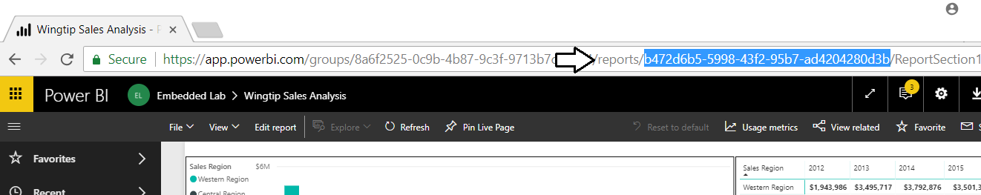

* 1. Copy the report ID into **EmbeddingConfigurationData.txt**.
  2. Navigate to the **Wingtip Sales Analysis** dataset inside the **Embedded Lab** app workspace to create a new report.
  3. Locate and copy the dataset ID from the URL by copy the GUID that comes after **/datasets/**.

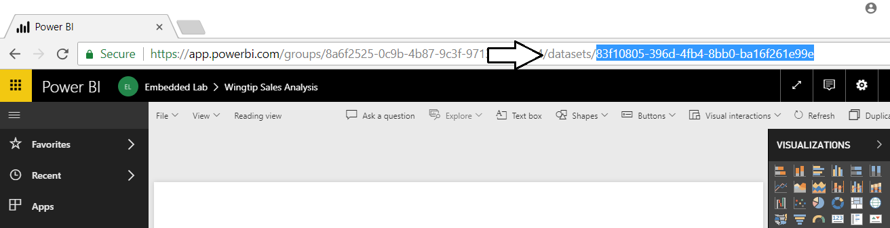

* 1. Copy the dataset ID into **EmbeddingConfigurationData.txt**.
  2. Navigate to the **Wingtip Sales Analysis** dashboard inside the **Embedded Lab** app workspace.
  3. Locate and copy the dashboard ID from the URL by copy the GUID that comes after **/dashboards/**.

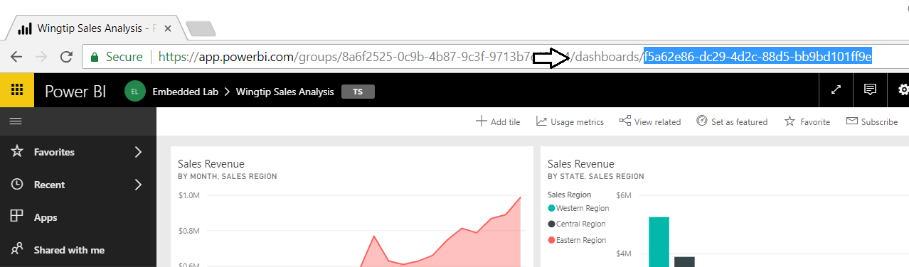

* 1. Copy the dashboard ID into **EmbeddingConfigurationData.txt**.
  2. You should have now updated **EmbeddingConfigurationData.txt** with all the configuration data you need with the exception of the client ID that you will create in the next exercise.

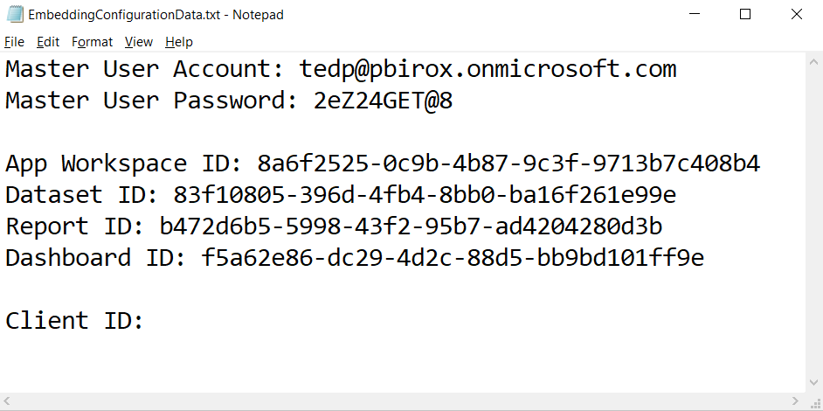

* 1. Save your changes to **EmbeddingConfigurationData.txt**.

### Exercise 2: Create a New SPFX Web Part Project

### Exercise 3: Call Power BI Service API using AadHttpClient

### Exercise 4: Embed a Power BI Report

### Exercise 5: Add a Report Toolbar

### Exercise 6: Embed a Power BI Dashboard

* Introducing Power BI and the Power BI Service API
* Calling the Power BI Service API using AadHttpClient
* Overview of the Embedding Features in Power BI
* Retrieving Embedding Data with the Power BI Service API
* Embedding Reports with the Power BI JavaScript API
* Writing Code to Interact with an Embedded Report